BASIC COMMANDS

1. PWD :- (Present working directory) It gives us the absolute path.

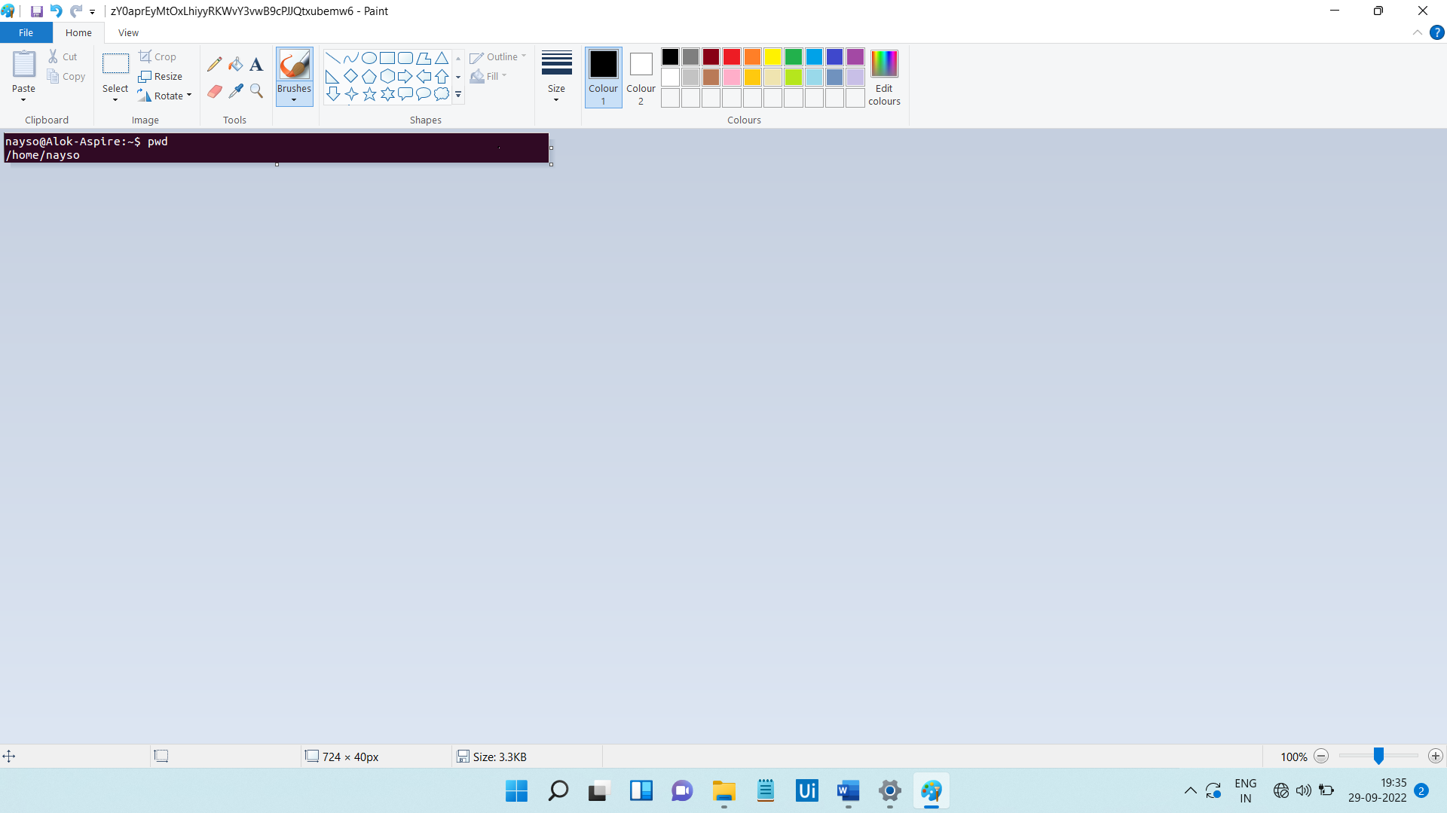

1. LS:- This command is used to know what files are in the directory you are in.

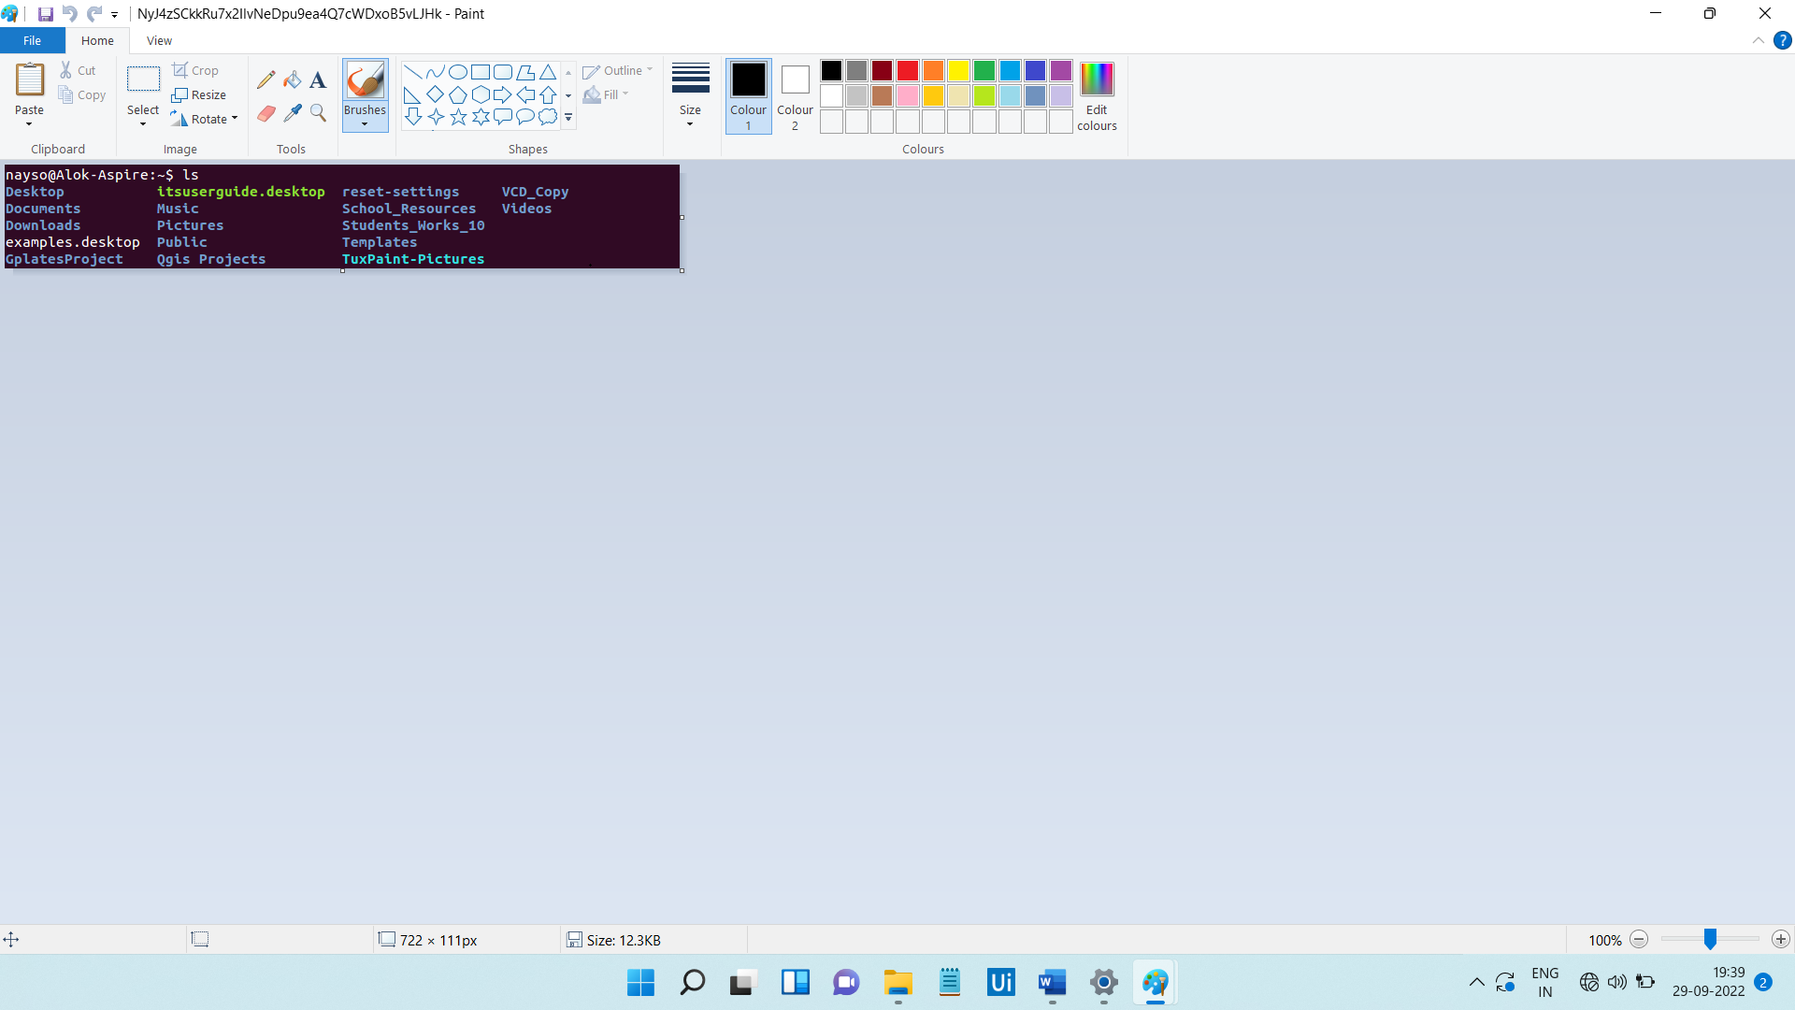

1. CD :- Change directory is used to go to a directory.



1. MKDIR :- This command is used to make a new directory under any directory .



1. RMDIR:- This command is used to delete directory.



1. TOUCH:- This command is used to create empty file.

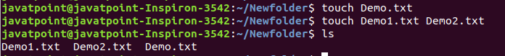

1. CAT COMMAND :- It is used to create a file, display content of the file ,copy the content of one file to another file, and more.

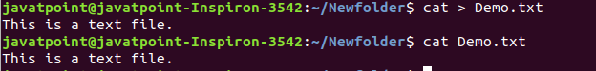

1. RM COMMAND :- This command is used to remove a file.



1. MV :- This command is used to move file or a directory from one location to another location.



1. CP:- This command is used to copy a file or directory.



1. RENAME COMMAND :- This command is used to rename a file.

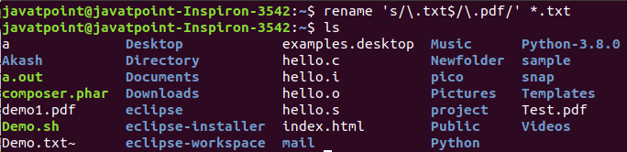

1. HEAD COMMAND :- It is used to display the content of a file.

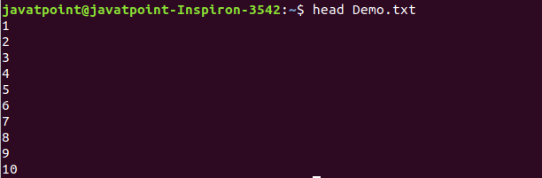

1. MORE COMMAND :- This command is quite similar to the cat command , as it is used to display the file content in the same way.

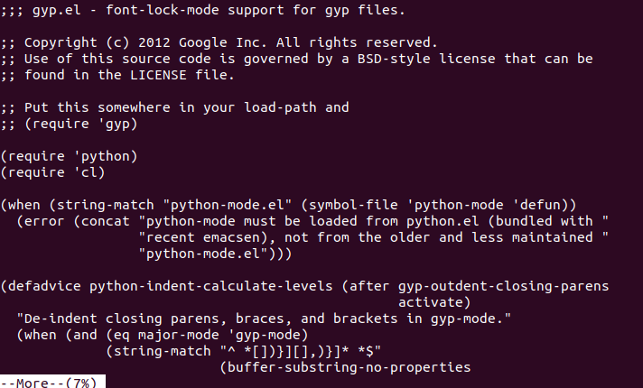

1. ID COMMAND :- Is used to display the user ID and group ID.

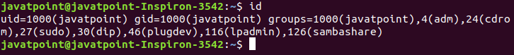

1. PASSWD COMMAND :- This command is used to create and change the password for a user.

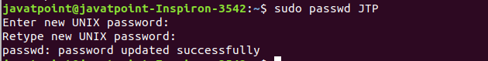

1. EXIT COMMAND :- This command is used to exit from the current shell.



1. CLEAR COMMAND:- It is used to clear the terminal screen.
2. WHOAMI :- This command tells you about the system username.

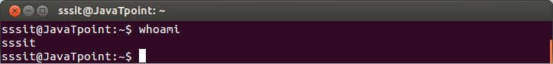

1. WHO :- This command gives the info about the user logged to the system .

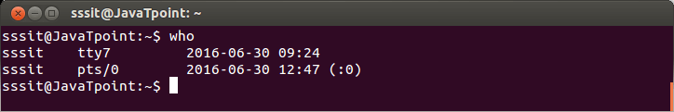

1. MAN COMMAND :- This command will tells you the list of commands.
2. CAT/ ETC/SHELLS:- This command tells us how many shells are in our system.